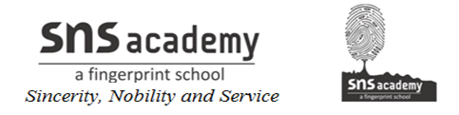

MONTHLY TEST- DECEMBER
MATHEMATICS

Class: VII Max Marks: 40
Date: 16.12.19 Time: 1 hr 30min
I. Fill in the blanks: (6 × 1= 6)
1) In a bar graph, the ________ of the bars should be equal.
2) The probability of a sure event is ___
3) The highest power of the variable in a linear equation is____
4) The probability of an impossible event is _____.
5) The empirical probability of an event can never be greater than _____ .
6) The value of ‘x’ in x + 3 = 5 is______ .
II. Answer the following: (5 × 2= 10)
7) A coin is tossed 250 times and we get a head 135 times and a tail115 times. Find the (a) probability of getting a head (b) probability of getting a tail.
8) Check whether y = -3 is a solution of 7y + 3 = 17 or not.
9) Write the equations for the following statements:
a) The difference of 3 times x and 5 is 25.
b) Three-fourths of y when added to 4 gives 16.
10) Write any one form of statement for the following:
a) y – 3 =11
b) 7p + 2 =12
11) Solve for ‘y’: 5y – 7=3

III. ANSWER THE FOLLOWING (4 X 3=12)
12) The following table shows the blood groups of 30 students of a class.
Blood groups | A | B | O | AB
No. of students | 11 | 9 | 3 | 7
Find the probability that the chosen student has blood group
(i) O (ii) B (iii) AB
13) Solve and verify your answer: 9x – 5(2x – 3) = 1 – 2x
14) Observe the bar graph and answer the questions that follow.
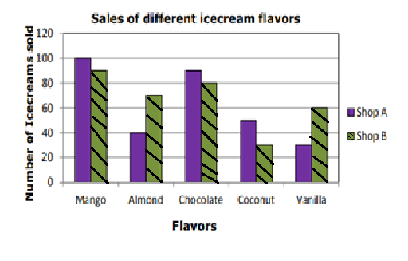
(a) Which flavor of ice-cream do people like most in shop A?
(b) Find the total numbers of Chocolate ice-creams sold by shop A and shop B.
(c) Find the total numbers of ice-creams sold by shop B?
15) Solve: . Verify the result.
IV. ANSWER THE FOLLOWING (3 X 4=12)
16) (a) Thrice a number when increased by 5 gives 50. Find the number.
(b) Find two consecutive natural numbers whose sum is 53.
17) The table shows weekly pocket money of students.
Pocket money in Rs | 75 | 100 | 125 | 150 | 175 | 200
No of students | 5 | 9 | 15 | 7 | 3 | 1
Find the probability that the weekly pocket money is
(a) less than 200 (b) more than 120
(c) less than 100 (d) more than 175
18) The performance of students in 1st Term and 2nd Term is given. Draw a double bar graph choosing appropriate scale:
Subject | English | Hindi | Maths | Science | Social Science
Term 1 | 67 | 72 | 88 | 81 | 73
Term 2 | 70 | 65 | 95 | 85 | 75

